Milestone Three

Model Creation

Michael Surdek
Southern New Hampshire University
DAT 650: Advanced Data Analytics
Professor Letia Sheldon
July 17, 2022
This data can now be fed into a basic test model to gauge the feasibility of the design and reveal any hidden details that should be addressed when we return to the data understanding and preparation phases. If the test model shows any predictive signal, it is then worth it to pursue a project on a larger scale that uses descriptive and predictive analytics to predict customers that may cancel and to understand what is causing the overall increase in churn. A random forest is a good fit for predicting customer churn based on the data that is currently available. It is a simple model to develop and can reveal prediction accuracy, variable importance, likelihood of churn, and false positive and false negative rates.
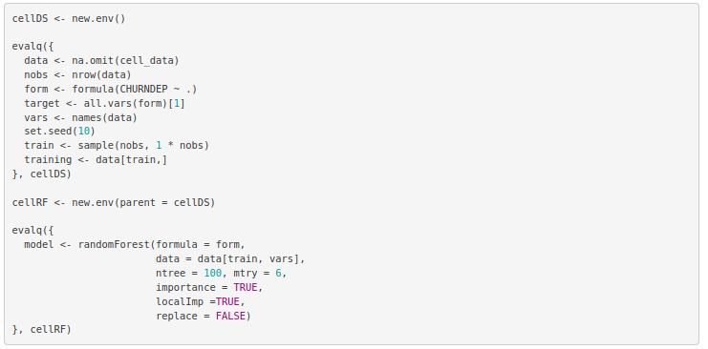
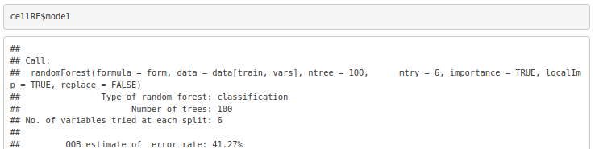
Calling the model shows that a collection of 100 decision trees has been created and that the majority of their votes can correctly predict whether or not a customer will churn with approximately 59% accuracy on the data with which it was trained. Looking further into the model, the confusion matrix shows that the random forest correctly predicts 57% of customers who have churned and 60% of those who have not. It also reveals that these predictions are significantly better than random guessing with no information.
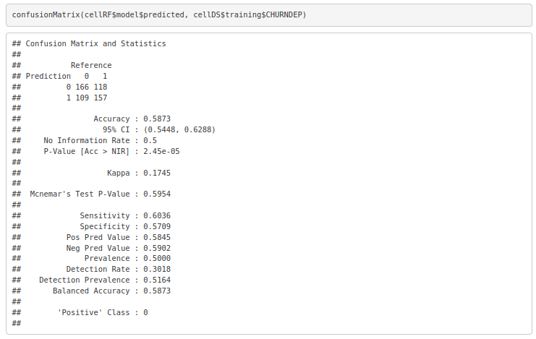
Another key output of the model is variable importance, which is measured as either the mean decrease in prediction accuracy from including each variable. This list shows the top 10 most important variables in the model, and these will be critical to improving the model further and understanding the true causes of customer churn.
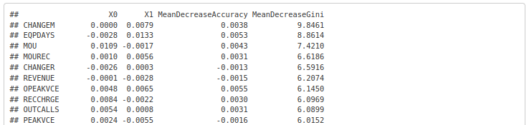
Finally, for GE to put the predictive model to use, the model can output the percentage of yes and no votes for any individual. This information can be combined with the original data to identify the specific customers that are most likely to churn. As an example, the top 10 most likely to cancel customers can be determined weekly, allowing GE to prioritize their outreach and approach those customers with alternative offers or potential resolutions to their concerns.
